Workshop 2 — Student Handout (Travel Destinations)

Task Type: HTML + CSS (Beginner)

Your Work: Complete the remaining 20% of the webpage

What you receive: 80% completed index.html and style.css

✅ What You Must Do (20% Work)

A. HTML Tasks
- Add role and aria-label for accessibility inside the navbar.
- Add missing alt text to all images (logo + destination images).
- Make the Home menu link active using a class.
- Fix the Sign in / Sign up links by adding proper class names and correct file links.
- Add the heading for the page ("Trending Destinations") below the navbar.
- Inside each card:
  - Add the price part
  - Add the button text

B. CSS Tasks
- Style the active link in the navbar.
- Style Sign in and Sign up buttons.
- Style the page heading.
- Style the price element inside each card.
- Style the button inside each card.

📌 Minimum Requirements (Checklist)
- Navbar accessibility attributes are added.
- All images have meaningful alt text.
- Home link is marked active.
- Sign in / Sign up links look correct and styled.
- Each destination card contains price + button.
- Footer contains at least two links.
- Page displays neat basic styling.
Given Output
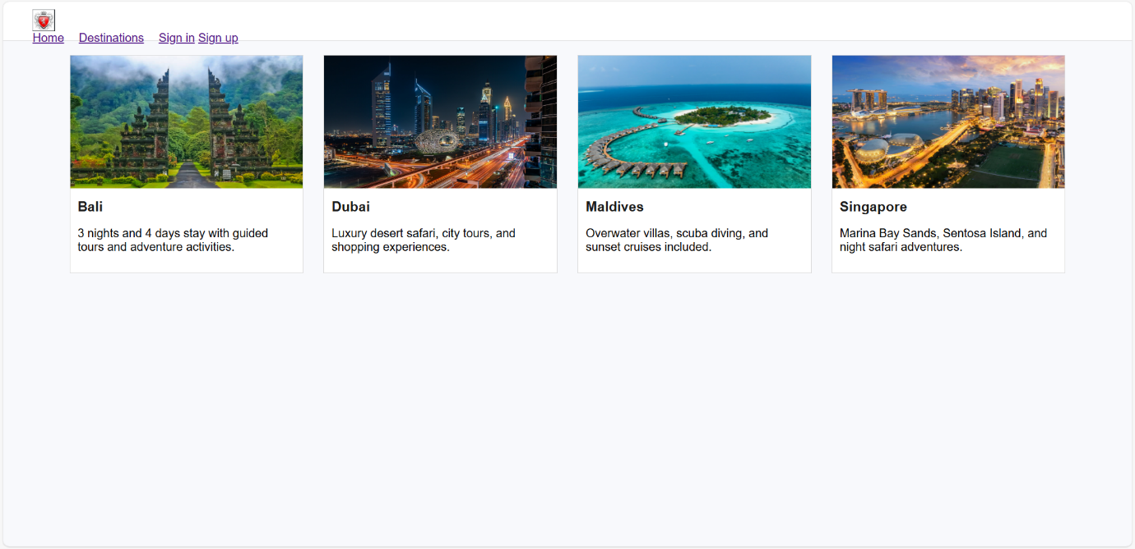
Expected Output
